Centre for Research Excellence (CRE) in Respiratory Health of Aboriginal and Torres Strait Islander Children
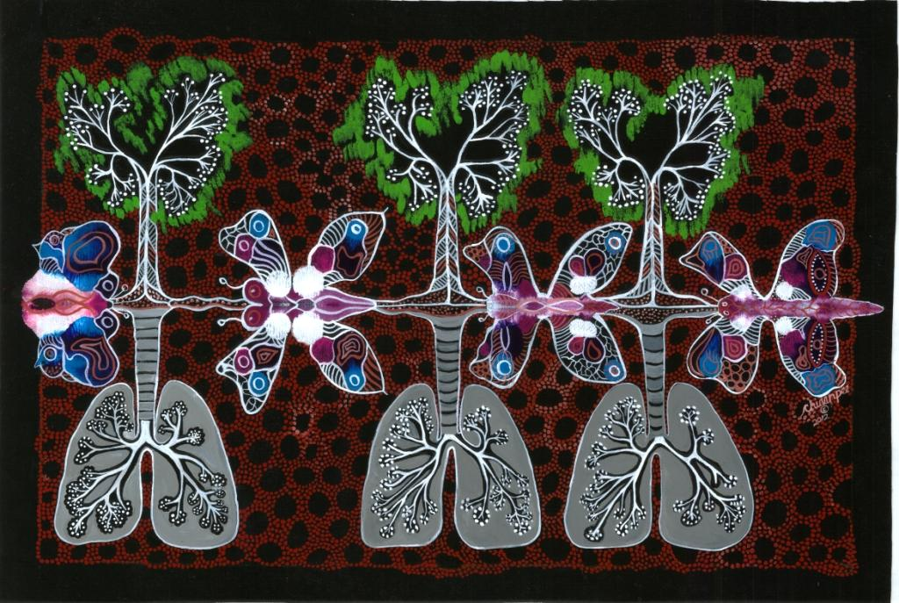

CRE FELLOWSHIP APPLICATION FORM
Fellowship term: 12 months commencing January 1st 2016
Fellowship award: $87, 004 (NHMRC PSP4)

Applicants are requested to:
- Read the Fellowship Guidelines and Conditions prior to completing this application form.
- Read any specific instructions listed in italics after relevant questions. Applicants must adhere to the maximum limits listed.
- Read the NHMRC Indigenous Research Excellence Criteria (http://www.nhmrc.gov.au/book/nhmrc-funding-rules-2015/6-assessment-criteria).
- Complete the application form electronically.
- Submit your completed application by the closing date by email as detailed below.
- Submit an original copy of your emailed application by post (including original signatures).

Enquiries and application submission by close of business on November 30th 2015 to:
Dr Deborah Holt
Business Manager
Centre for Research Excellence in Respiratory Health of Aboriginal and Torres Strait Islander Children
Menzies School of Health Research
PO Box 41096
Casuarina NT 0811
CRE.Indigenous.Lung@menzies.edu.au

Section 1 – Applicant details

Applicant name:

Current appointment(s):

Current contact details:
Department
Institution
Address
Phone
Email

Do you have any planned periods of absence during the fellowship: |  | Yes No  If yes, provide details:
PhD: |  | Awarded Submitted
Date PhD awarded/submitted:

Title of PhD project:

Institution PhD undertaken:
*If different to current details.
Department
Institution

PhD supervisor(s):

Are you an Australian citizen or Permanent Resident?:  *You must be an Australian citizen or permanent resident to be eligible for this fellowship. Proof may be required. |  | Australian citizen  Permanent Resident
Have you had any period of career disruption?:  If yes, please state the dates of disruption and any associated FTE during that time.  *Add further disruptions as needed. |  | Period of disruption:  FTE for the period:  (ie total absence = 0% FTE)
Academic qualifications:
*Add further lines if necessary.
Year | Qualification |  | Institution
Career history:
*Add further lines if necessary.
Year(s) | Position |  | Institution
Professional activities and memberships:
*Add further lines if necessary.
Year(s) | Organisation |  | Role
Publications:
*Please provide your full publication list and asterisk publications relevant to this application.
*Please bold your name.
CTION ONE:
Presentations:
*Provide details of presentations you have made in the last five years.
*Add further lines if necessary.
Year | Presentation type (eg oral, poster) and title |  | Forum (eg conference)
Supervision:
*Provide details of your supervision of staff and students.
*Add further lines if necessary.
Year(s) | Staff/student name, institution, project title, staff/student role and your role
External funding:
*Please list all current and past external funding, including project and person funding.
*Add further lines if necessary.
Grant 1
Year(s):
Investigator(s):
Title:
Funding source:
Grant type:
Total amount:
Grant 2
Year(s):
Investigator(s):
Title:
Funding source:
Grant type:
Total amount:
Prizes and awards:
*Include prize or award amount if applicable.
*Add further lines if necessary.
Year | Prize or award title

Section 2 – Supervisor details

Applicant supervisor:
*Supervisor must be a CRE Chief Investigator.
Supervisor name:
Supervisor institution:
*If different to applicant current details.
Department
Institution
Address

Was this supervisor your PhD supervisor?: | Yes No
Applicant associate supervisor:
*Add further associate supervisors as required.
Associate supervisor name:
Associate supervisor institution:
*If different to applicant current details.
Department
Institution
Address

Associate supervisor expertise:
*Provide details of the expertise your associate supervisor provides to your project.
Associate supervisor publications (last 5 years):
*Not required if associate supervisor is a CRE Chief or Associate Investigator.

Section 3 – Project details

Scientific project title:

Project location:
*If different to supervisor institution.
Department
Institution
Address

Is this the same institution as where you completed your PhD?: | Yes No
Lay project title:

Lay project description:
*Suitable for use on a web site.
*500 words maximum.
Relevance of project to respiratory health of Aboriginal and Torres Strait Islander children:
*100-200 words
Project aims and hypotheses:
*½ page maximum.

Project background, research plan and timeline:
*5 page maximum.
Significance and innovation:
*1 page maximum.
*Describe the importance of the problem and the potential significance of the research. Describe how the anticipated outcomes will advance the knowledge base and how the project is novel and innovative.

Criteria for Indigenous Health Research:
*See the cover page for further details on where to find more information.
*2 page maximum.
Community engagement

Benefit

Sustainability and transferability

Building capability

References:
*1 page maximum.

Section 4 – Previous experience and future potential

Previous experience:
Please provide details of your previous experience highlighting the most significant contributions you have made to your field of research.
*1500 characters maximum.
Please provide details from your previous experience that most significantly affect your research proposal.
*1500 characters maximum.
Outline any previous experience relevant to Indigenous health.
*1500 characters maximum.
Future potential:
Describe the potential of this research project and choice of supervisor to extend your knowledge and skills.
*1200 characters maximum.
Describe how this award would contribute to your future career aspirations.
*1200 characters maximum.
Indicate how the research topic relates to your current and future professional pathway.
*1200 characters maximum.

Section 5 – Assessors

Nomination of potential assessors:
*Please provide the names and contact details of two potential assessors who will have no conflict of interest with the project or the applicant.
Assessor 1
Name
Department
Institution
Address
Phone
Email
Area of expertise
Assessor 2
Name
Department
Institution
Address
Phone
Email
Area of expertise

Section 6 – Declarations

Declaration by applicant:  I declare that to the best of my knowledge, the information supplied herein is correct and complete. I acknowledge that the submission of incorrect or incomplete information may result in a cancellation of approved funding at any stage. I recognise that it is my responsibility to provide all necessary documentary evidence of my qualifications and experience, and authorise the CRE to conduct reference checks if required.  I understand that if awarded this fellowship, I will be required to actively participate in all CRE activities and to observe the CRE ethos of capacity building and improving the respiratory health of children, particularly Aboriginal and Torres Strait Islander Children. If I am awarded this funding I understand that I am expected to continue to apply for external funding and adhere to the terms and conditions of this fellowship.  I confirm that I have: | Name:  Signature:  Date:  Read the Fellowship Guidelines and Conditions.  Obtained all required original (pen to paper) signatures.  Referred to the start of this document for submission requirements.
Declaration by supervisor:  I declare that I have agreed to supervise the applicant on the project detailed above and that I have sufficient time to devote to the applicant and the project. I declare that sufficient resources are available at the named institution to complete the project. | Name:  Signature:  Date:
Declaration by associate supervisor:  I declare that I have agreed to co-supervise the applicant on the project detailed above and that I have sufficient time to devote to the applicant and the project. | Name:  Signature:  Date:

